**Module 2: Git Assignment – 1**

1. Launched an EC2 instance

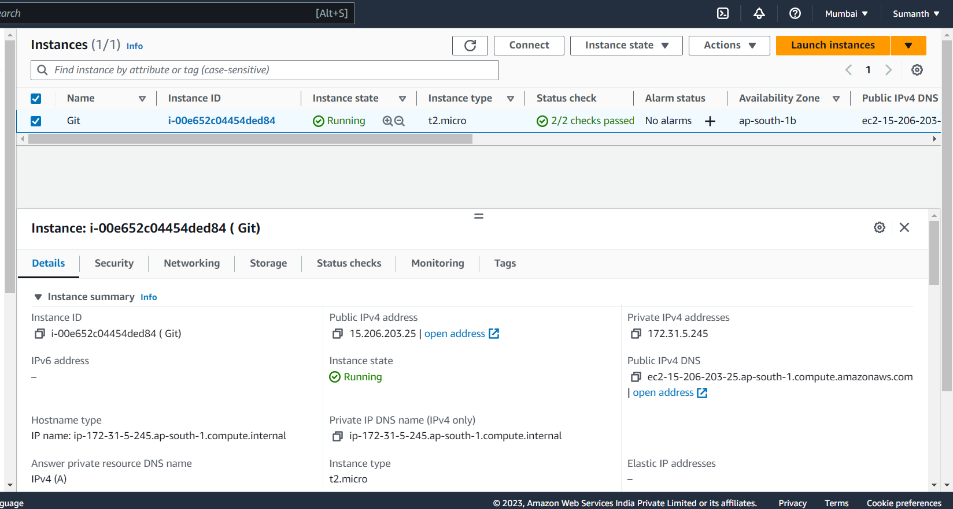

1. Created a new folder

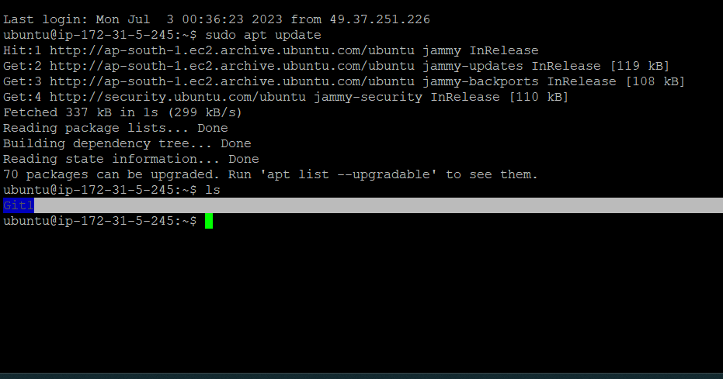

1. Created 3 files inside the folder

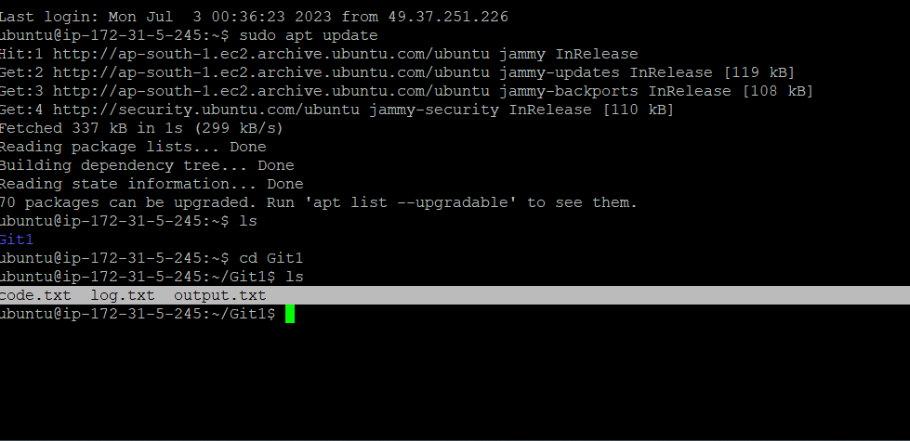

1. Finally staged, commited and pushed the mentioned files to Github

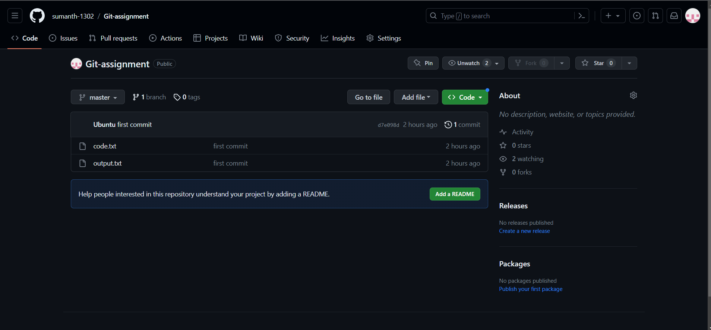

* **The Commands for above points are :**

1. mkdir Git1
2. ls
3. cd Git1
4. git init
5. nano code.txt
6. ls
7. nano log.txt
8. ls
9. nano output.txt
10. ls
11. git status
12. git add code.txt
13. git status
14. git add output.txt
15. git status
16. git commit -m "first commit"
17. git branch
18. git remote add origin https://github.com/sumanth-1302/Git-assignment.git
19. git push origin master